Depth First Search for Graphs and Trees

Python.file:

Screenshot:
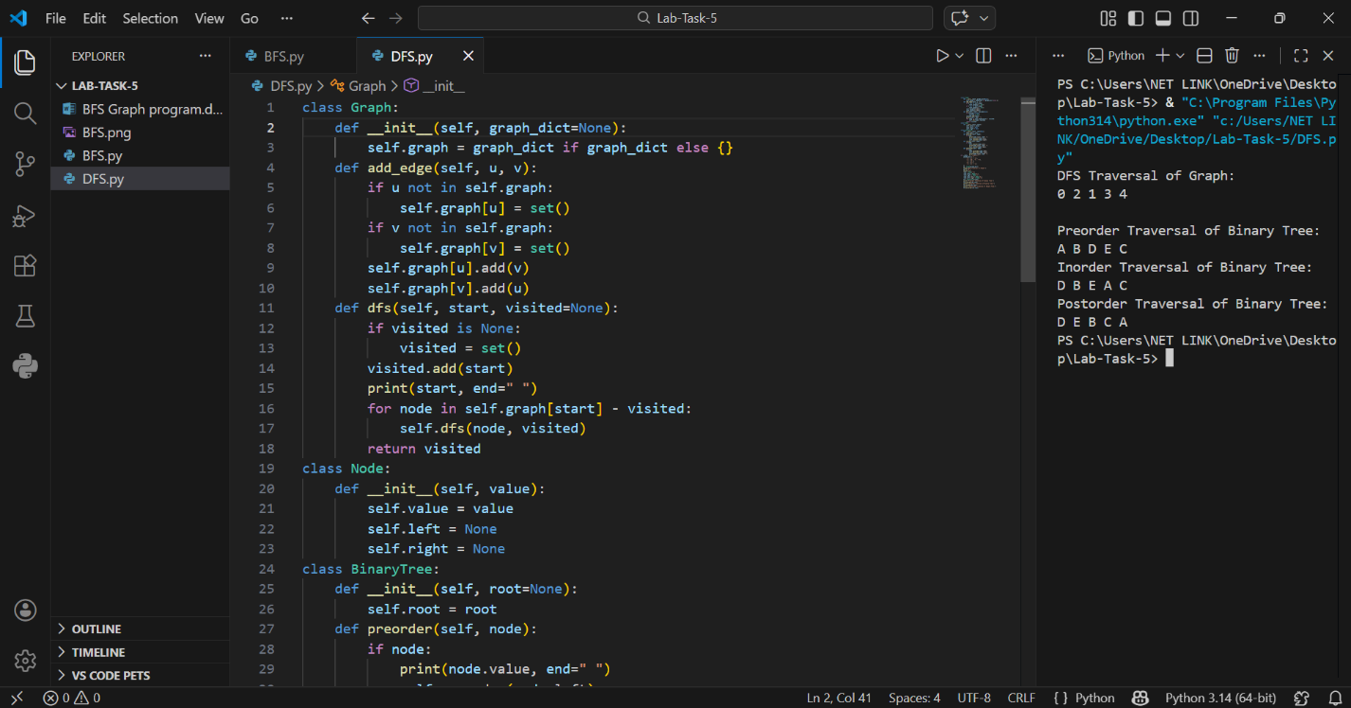

Details:
This Python program implements Depth First Search (DFS) traversal on a graph as well as DFS traversals (Preorder, Inorder, Postorder) on a binary tree using Object-Oriented Programming (OOP). The program demonstrates how graphs and trees can be traversed recursively, encapsulating data and behavior within classes.
It allows the user to:
• Create a graph and add edges
• Perform DFS traversal on the graph
• Create a binary tree
• Perform Preorder, Inorder, and Postorder DFS traversals on the tree
The program runs in the terminal.

Main Components:
• Graph Class (Graph) – stores the adjacency list of the graph and provides DFS traversal method.
• Node Class (Node) – represents a node of a binary tree with left and right children.
• BinaryTree Class (BinaryTree) – provides methods for Preorder, Inorder, and Postorder traversals.
• Set – used to track visited nodes in graph DFS.
• Recursion – used in both graph and tree DFS methods.

How the Program Works:

1️. Graph DFS:
- A Graph object is created with a dictionary representing nodes and edges.
- Edges are added using add_edge(u,v) method.
- DFS traversal starts from a given node.
- A set called visiteded keeps track of already visited nodes.
- The algorithm recursively visits all unvisited neighbors, printing nodes in DFS order.

2️. Binary Tree DFS:
- A binary tree is created using Node objects.
- A BinaryTree object is initialized with the root node.
- Preorder Traversal: Visit root → left subtree → right subtree.
- Inorder Traversal: Visit left subtree → root → right subtree.
- Postorder Traversal: Visit left subtree → right subtree → root.
- Each traversal prints the nodes in the corresponding DFS order.

